CSC 428 / CSC 2514h – Human-Computer Interaction

Assignment 2: Controlled Experiment

Smartwatch Keyboard

Yufeng Li

# Introduction/Motivation

Smartwatches have become a trend and both Google and Apple are designing OS for them. As an OS, it’s very common to process inputs from all required sources, one of them is text inputs. Though it’s a uncommon need to type on a smartwatch, I devise 2 different text entry techniques to the operating system. The miniature keyboard is a traditional keyboard where users enter numbers by tapping on the keys of a miniature keyboard. The zooming keyboard is a new keyboard design where users can first tap to zoom into a section of the keyboard, and then tap on the desired character. I will conduct experiments with 4 different participants and analyze the data being gatthered to conclude which is a better technique to input text on a smartwatch.

# Methodology

The task for every participant is to finish trials I prepared for the experiment. I will set up the keyboard on a phone with touch screen. If the participant need help to place the phone on his/hers wrist, I will help to do so. The process of gathering data is automated, I, the investigator, will only focus on conduct the experiment and change conditions. The experiment will be within-subjects which means every participant will face all conditions. My choices of independent variables are **text input types** and **movement status**. They each have 2 different possible values which are alphabetical text(less than 5 words) or numeric&symbolic text(15 characters since they are hard to distinguish on smartwatch), and in a moving status or in a still status respectively. The reason why I choose them is because Alphabetical characters looks very different from others while symbolic&numeric characters are not. This stronger contrast can make users better distinguish characters on a small screen. Since it’s a watch, there will be scenarios where people need to type when they are not standing still or sitting. Moving screens can be very blurry for users to see. By adding 2 different keyboards, I have 8 different conditions. Since I have only 4 participants, I will use randomization to present conditions to them since there are far more conditions than participants. I will use the following structure to present trails:

# Hypothesis

* There is no difference in mean time to complete typing using normal miniature keyboard vs. zooming keyboard.
* There is no difference in mean accuracy to complete typing using normal miniature keyboard vs. zooming keyboard.

# Results and Analysis

1. **Hypothesis 1**

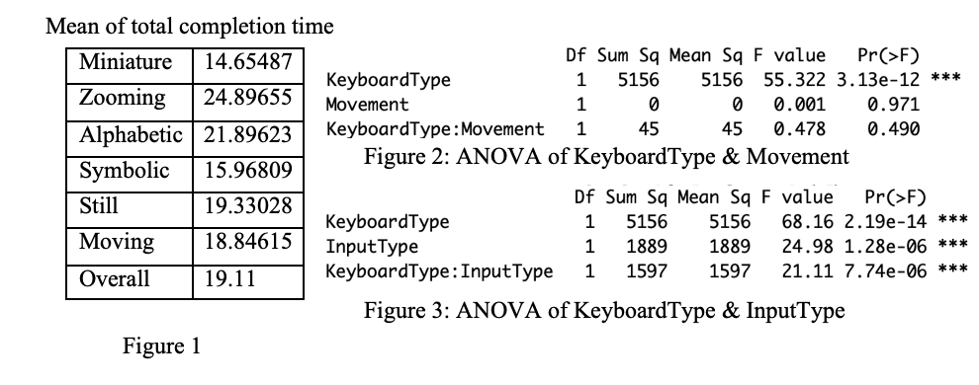

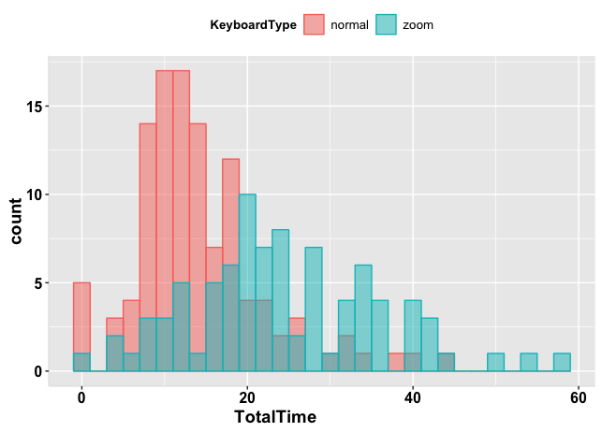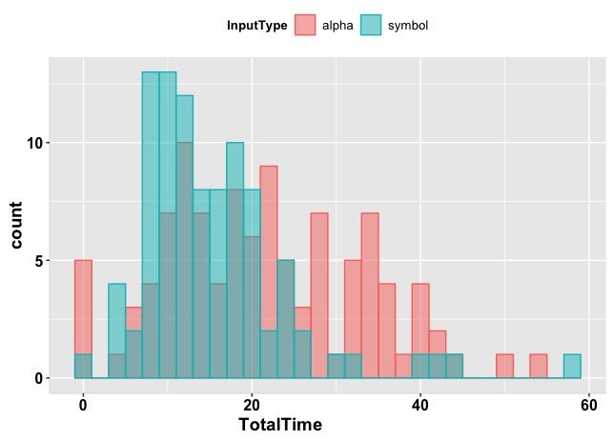

Figure 4 Figure 5

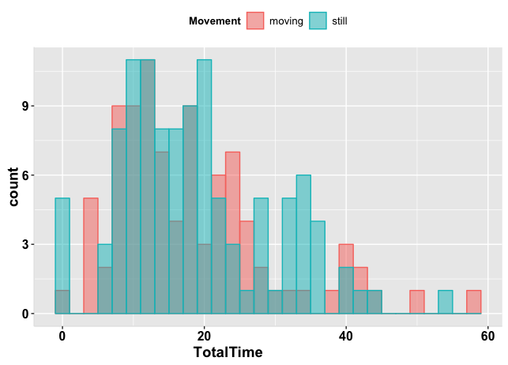The grand mean for typing completion time was 19.11s. Normal miniature keyboard was the faster keyboard at 14.65487s, while zooming keyboard was the slower one at 24.89655s. This tendency can be also seen in Figure 4. The main effect of keyboard on typing completion time was statistically significant(F=55.322 p<0.001 &F=68.16 p<0.001). However, the movement effect was almost none. When type in still position, the mean completion time was 19.33028s while in moving status it was a bit faster at

Figure 6 18.84615s. Shown in Figure 6, their completion time

shares a similar tendency. The main effect of movement on typing completion time was statistically insignificant(F=0.001 p>0.5). There was no interaction between keyboard type and movement status(F=0.478 p>0.5). The input type effect was very significant. When typing alphabetical text the mean completion time was 21.89623s while symbolic is faster at 15.96809s. Shown in Figure 5, symbolic&numeric text had a faster typing time than that of alphabetical text. The main effect of input type on typing completion time was statistically significant(F=24.98 p<0.001). There was huge interaction between keyboard type and movement status(F=21.11 p<0.001). Overall, the miniature keyboard finish typing faster than the zooming keyboard and input type is a very important factor which symbolic&numeric text will complete typing faster.

1. **Hypothesis 2**

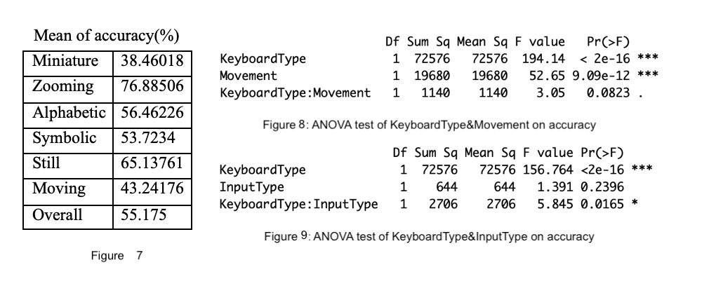

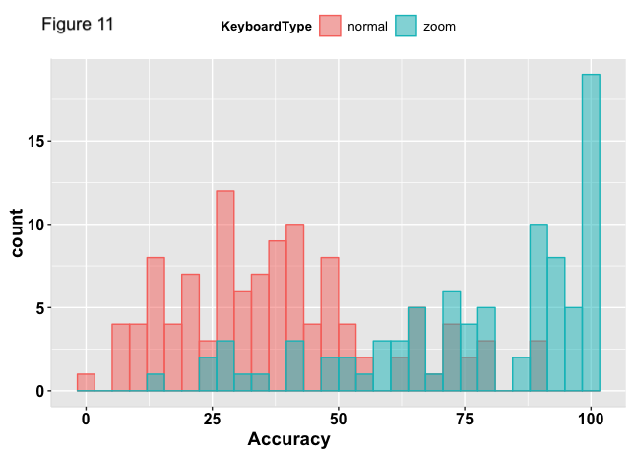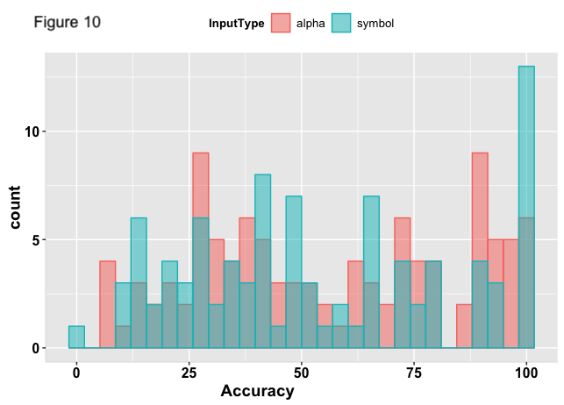

The grand mean for accuracy was 55.175%. Zooming keyboard was the more accurate keyboard at 76.88506, while normal miniature keyboard was the worse one at 38.46%. This tendency can be also seen in Figure 11. The main effect of keyboard on typing completion time was statistically significant(F=194 p<0.001 &F=156.764 p<0.001). However, the input type effect was almost none. When type alphabetical text, the mean accuracy 56.46% while typing symbolic&numeric text, it was a less accurate at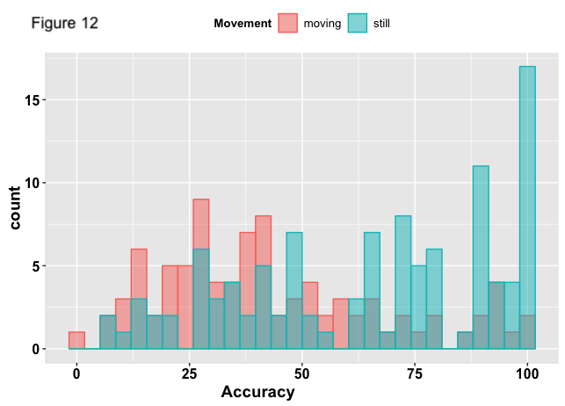 53.72%. Shown in Figure 10, their completion time shares a similar tendency. The main effect of input type on typing completion time was statistically insignificant(F=1.391 p>0.1). There was more than a little interaction between keyboard type and movement status(F=5.845 p<0.1). The movement status was very significant. When typing still the mean accuracy was 65.14% while moving is less accurate at 43.25%. Shown in Figure 12, typing still was a more accurate typing position. The main effect of movement status on accuracy was statistically significant(F=52.65 p<0.001). However, there was little interaction between keyboard type and movement status(F=3.05 p<0.1). Overall, the zooming keyboard was more accurate at typing than miniature keyboard. The movement status affects the accuracy for certain, however, it has little to do with the keyboard types. The input type still has effects on the accuracy, however, they performs almost same in terms of accuracy.

1. **Within-subjects design? Between-subjects design?**

I noticed that no matter how I randomized the conditions, the participants will eventually perform faster and better under the last 2 or 3 conditions. Thus the learning speed is a compounding factor to influence experiments. Between-subjects design can rule out this effect because the participant don’t enough time to get use to the keyboard provided that each experiment has only 8 trials in my experiment design. Since I only have 8 conditions, it is reasonable to find 8 participants. However, if I have more conditions, this will result in more participants needed.

# Conclusion

Overall, miniature keyboard has strength in speed but sacrifices accuracy, and zooming keyboard has strength in accuracy but sacrifices speed. Based on my analysis, I think it would be better if the miniature keyboard will be using to type symbolic&numeric text and the zooming keyboard will be using to type alphabetic text. Thus it can speed up the symbolic&numeric text typing speed at the cost of little accuracy loss.

# Appendix:

Data collected(only 10 lines selected):

| **X** | **Userid** | **KeyboardType** | | **InputType** | | **Movement** | | **TotalTime** | | **LongestPause** | | **Accuracy** | |
| --- | --- | --- | --- | --- | --- | --- | --- | --- | --- | --- | --- | --- | --- |
|  |  |  |  | |  | |  | |  | |  | |  |
| **1** | 0 | p2 | normal | | symbol | | moving | | 9 | | 5 | | 14 |
| **2** | 1 | p1 | zoom | | alpha | | moving | | 27 | | 3 | | 94 |
| **3** | 2 | p3 | normal | | alpha | | still | | 17 | | 2 | | 72 |
| **4** | 3 | p2 | zoom | | alpha | | still | | 23 | | 2 | | 90 |
| **5** | 4 | p1 | normal | | symbol | | moving | | 20 | | 7 | | 67 |
| **6** | 5 | p3 | normal | | symbol | | still | | 17 | | 6 | | 67 |
| **7** | 6 | p3 | normal | | alpha | | still | | 15 | | 2 | | 76 |
| **8** | 7 | p4 | zoom | | alpha | | moving | | 28 | | 2 | | 56 |
| **9** | 8 | p1 | normal | | alpha | | still | | 0 | | 2 | | 74 |
| **10** | 9 | p3 | zoom | | alpha | | moving | | 28 | | 3 | | 79 |

Output by R script:

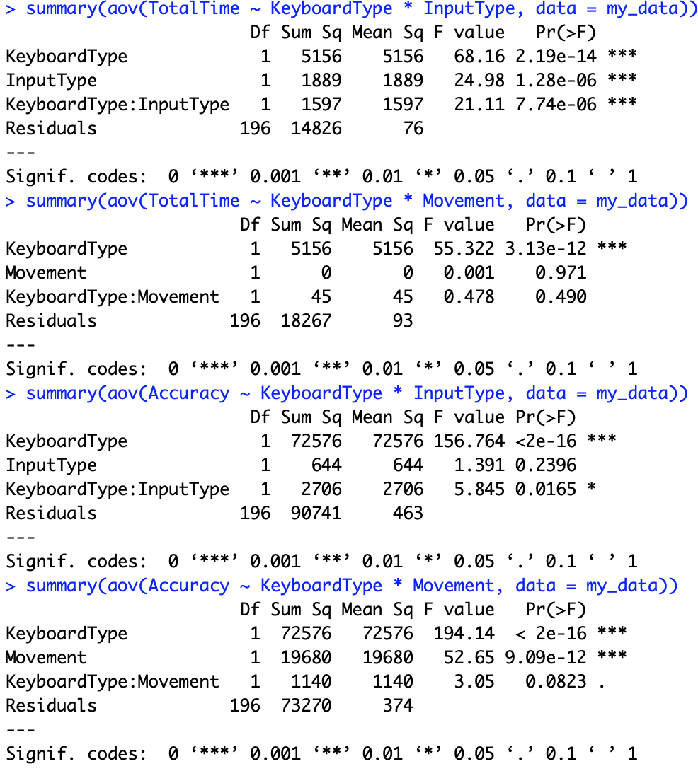





consent forms:

